**GIT** (https://help.github.com/)

**Set Up Git** (<https://help.github.com/articles/set-up-git/>)

1. Download and install the latest version of GitHub for Windows. This will automatically install Git and keep it up-to-date for you.
2. On your computer, open the Git Shell application.
3. Tell Git your name so your commits will be properly labeled. Type everything after the $ here:

*git config --global user.name YOUR NAME*

1. Tell Git the email address that will be associated with your Git commits. The email you specify should be the same one found in your email settings. To keep your email address hidden, see "Keeping your email address private".

*git config --global user.email YOUR EMAIL ADDRESS*

**Create a new repository on GitHub** (<https://help.github.com/articles/create-a-repo/>)

To put your project up on GitHub, you'll need a repository for it to live in. Let's create one!

New repository menuIn the upper-right corner of any page, click , and then click New repository.

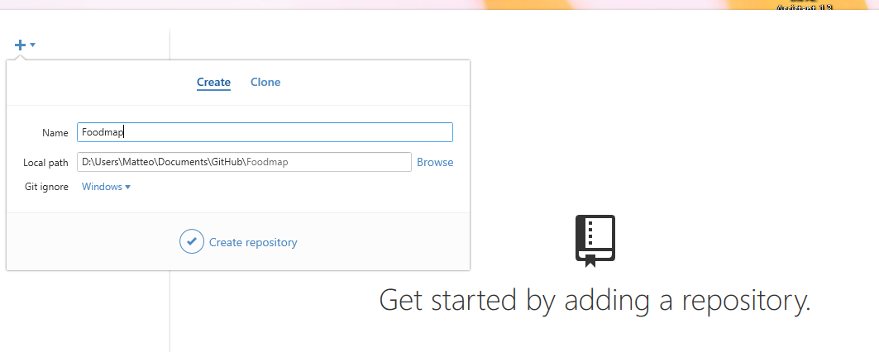

**Da shell**

Posizionarsi sulla directory root del repository

*cd d:/Users/Matteo/Documents/GitHub*

*git init*

**Aggiungere il progetto al repository**

*cd ./Foodmap*

*git add *.\**

*git commit -m 'Secondo commit GIT'*

***Pubblicazione del progetto***

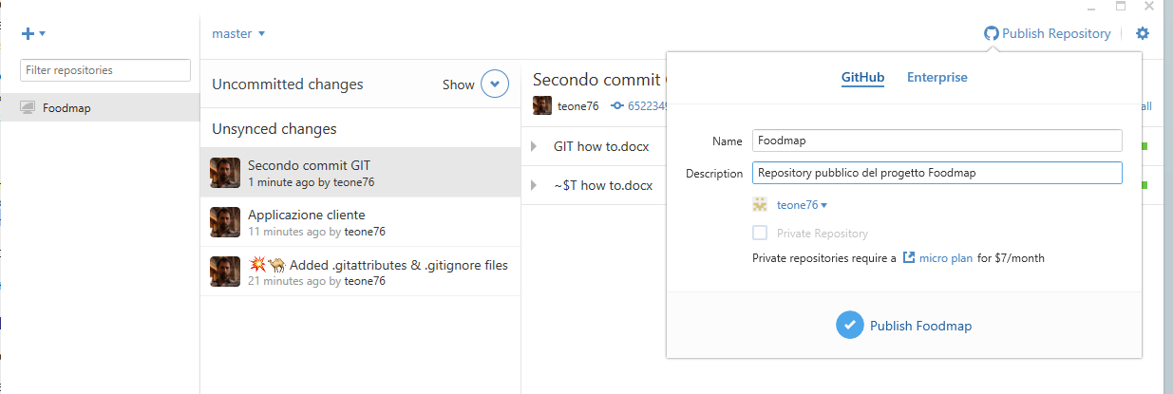

Url del repository:

*https://github.com/teone76/Foodmap.git*

**Clonare il repository in locale**

*git clone https://github.com/teone76/Foodmap.git ./myDirectory/*

**Sincronizzare il repository**

*Per ogni info chiedere a Francesco*